# Error Detection and Correction

## Types of Errors

1. Describe the two types of errors that have been explained in the lecture.

## Parity Check

1. Determine the parity bits for the following bit sequences. All sequences are 7 bit long.

0110101 1101010 1010111 1100110 1000100 0111001 1110011

* 1. Apply even parity.
  2. Apply 2-dimensional even parity.
  3. What are the advantages and disadvantages of 1-dimensional and 2-dimensional parity?

## Cyclic Redundancy Check (CRC)

1. Suppose we want to transmit the message 1011001001001011 and protect it from errors using the CRC-8 polynomial x8+x2+x+1.
   1. Use polynomial long division to determine the message that should be transmitted.
   2. What kind of errors will this polynomial be able to detect?
   3. Suppose the leftmost bit of the message is inverted due to noise on the transmission link. What is the result of the receiver’s CRC calculation? How does the receiver know that an error has occurred?

## Checksum

1. Determine the checksum for the following bit sequence. Assume a 16-bit segment size.

10010011 01101100 11001001 10101101 10011000 00111101

1. A burst error has altered the sequence during transmission. The following sequence has been received. Perform the calculations for the receiver.

10010011 01101100 11001100 10001101 10011000 00111101

## Hamming Code

1. Encode the following bit sequences using the Hamming code:

1001011 1101100 1001001

1. A decoder for Hamming code receives the following bit sequence: 111010100000. Determine the data bits contained in the bit sequence and verify their correctness.

# High-Level Data Link Control (HDLC)

1. The High-Level Data Link Control (HDLC) protocol defines a number of types of frames shown in figure 1. Explain a) the general layout of HDLC frames, b) the use of the frame types to implement flow control concepts such as Stop-and-Wait ARQ and Selective Repeat ARQ, and c) the terms piggybacking and bit stuffing.

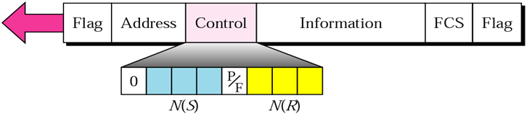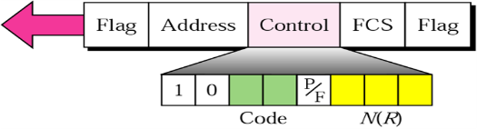

I-Frame

S-Frame

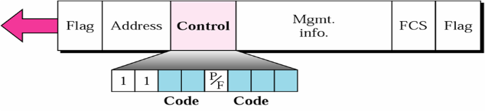

U-Frame

**Figure 1: Types of HDLC frames**

1. Assume that station 00001100 will send a 200 byte response using HDLC. Write out the complete frame for HDLC. Where information such as sequence numbers, etc is not given, choose a number and explain your choice.

## Exam Question

Assume you have connections with the following characteristics:

1. A connection that exhibits sporadic bursts of errors. Transmissions over this connection are not costly and the transmission delay and round-trip-time are considered to be short.
2. A connection that exhibits few errors which are generally limited to single bits. Transmissions over this connection are costly and the transmission delay and round-trip-time are considered to be long.

Propose an error detection approach for the connections in i) and an error detection approach for connections in ii) and explain the details of each approach. Justify your choice and contrast it against an alternative that would not be as suitable as your choice.